**Assignment 1**

**Problem Statement :-**

Suppose you are given the following requirements for a simple database for the National Hockey League (NHL).

* The **NHL** has many teams, each team has a name, a city, a coach, a captain and set of players.
* Each player belongs to only one team.
* Each player has a name, a position (such as left wing or goalie), a skill level and a set of injury records
* A team captain is also a player.
* A game is played between two teams and has a date and a score.

**Report:**

Detailed report regarding the result of the matches between a specified time interval.

**---: SOLUTION :---**

**Section (A): Database Design**

**(A.1) ER Diagram Design :-**

To solve the problem, first we design the ER diagram. For creating ER diagram, we are following some steps –

**Step 1:** Finding the Entity sets

After reading that statement, we found that there are 3 entity sets available.

* **Team**
* **Player**
* **Game**

**Step 2:** Finding the Relations between Entity sets

* Between **Team** and **Player** there is a relation named “**Plays for**”.
* Between **Team** and **Player** there is a relation named “**Lead by**”.
* Between **Team** and **Game** there is a relation named “**Played**”.
* Between **Player** and **Game** there is a relation named “**Injured in**”.

**Step 3:** Finding Cardinality sets

* The relation “**Plays for**” between **Team** and **Player** has ‘**one to many**’ relationship.
* The relation “**Lead by**” between **Team** and **Player** has ‘**one to one**’ relationship.
* The relation “**Played**” between **Team** and **Game** has ‘**2…n to many**’ relationship.
* The relation “**Injured in**” between **Player** and **Game** has ‘**many to many**’ relationship.

**Step 4:** Finding the Attribute Sets

* **Team:** tid, tname, city, coach.
* **Player:** pid, pname, position, skill.
* **Game:** gid, date.

**Step 5:** ER Diagram Draw

**Lead by**

**1**

**1**

**Team**

**1**

**Plays for**

**Player**

**2..n**

**m**

**m**

**Played**

**m**

**Injured in**

**m**

**Game**

**Fig:- F1.1**

**(A.2) Schema Design :-**

After creating the ER Diagram, now we have to create the schemas. Now for creating the schemas we have to take some assumptions form the ER diagram.

**(A.2.1) Assumptions form ER Diagram (Fig F1.1) :-**

1. In the relation “**Plays for**” to establish the ‘**one to many**’ relationship we take ‘tid’ from team entity and set a reference into the **Player** entity.
2. For the relation “**Lead by**” of ‘**one to one**’we create another entity called **Team_Captain** where ‘tid’ as foreign key form the entity **Team** and ‘pid’ named ‘cid’ also as foreign key from **Player**.We make ‘tid’ primary key for the **Team_Captain** entity.
3. For the relation “**Played**” of ‘**2…n to many**’ relationship we create another entity set called **Game_Result** and ‘tid’ as foreign key form **Team** entity and ‘gid’ as foreign key from **Game** entity and make them both a composite primary key of that entity. In this entity another attribute is added named by ‘score’.
4. For the relation “**Injury**” of ‘**many to many**’ relationship we create another entity called **Injury** here we take ‘pid’ as foreign key from **Player** and ‘gid’ as foreign key from **Game** and make them both a composite primary key of that entity. In this entity another attribute is added named by ‘inj_nm’.

**(A.2.2) Schemas :-**

* **Team** ( tid, tanme, city, coach )
* **Player** ( pid, pname, position, skill, tid )
* **Team_Captain** ( tid, cid )
* **Game** ( gid, date )
* **Game_Result** ( gid, tid, score )
* **Injury** ( pid, gid, inj_nm )

Now we get our all schemas and it seems that all schemas are normalised up to **3NF**. We don’t normalise it further.

**(A.3) Source Code for the Database :-**

All schemas are designed and normalised, now we create those schemas into the mysql database.

**Table Creation :-**

**Team Table**

MariaDB [assignment1]> create table team(tid varchar(4) primary key,tname varchar(20),city varchar(15),coach varchar(20));

Query OK, 0 rows affected (0.573 sec)

MariaDB [assignment1]> desc team;

**| Field | Type | Null | Key | Default | Extra |**

| tid | varchar(4) | NO | PRI | NULL | |

| tname | varchar(20) | YES | | NULL | |

| city | varchar(15) | YES | | NULL | |

| coach | varchar(20) | YES | | NULL | |

4 rows in set (0.148 sec)

**Player Table**

MariaDB [assignment1]> create table player(pid varchar(4) primary key,pname varchar(20),position varchar(15),skill int(2),tid varchar(4) references team(tid));

Query OK, 0 rows affected (0.347 sec)

MariaDB [assignment1]> desc player;

**| Field | Type | Null | Key | Default | Extra |**

| pid | varchar(4) | NO | PRI | NULL | |

| pname | varchar(20) | YES | | NULL | |

| position | varchar(15) | YES | | NULL | |

| skill | int(2) | YES | | NULL | |

| tid | varchar(4) | YES | | NULL | |

5 rows in set (0.077 sec)

**Team_Captain Table**

MariaDB [assignment1]> create table team_captain(tid varchar(4) references team(tid),cid varchar(4) references player(pid),primary key(tid));

Query OK, 0 rows affected (0.306 sec)

MariaDB [assignment1]> desc team_captain;

**| Field | Type | Null | Key | Default | Extra |**

| tid | varchar(4) | NO | PRI | NULL | |

| cid | varchar(4) | YES | | NULL | |

2 rows in set (0.093 sec)

**Game Table**

MariaDB [assignment1]> create table game(gid varchar(4) primary key,date date);

Query OK, 0 rows affected (0.449 sec)

MariaDB [assignment1]> desc game;

**| Field | Type | Null | Key | Default | Extra |**

| gid | varchar(4) | NO | PRI | NULL | |

| date | date | YES | | NULL | |

2 rows in set (0.089 sec)

**Game_Result Table**

MariaDB [assignment1]> create table game_result(gid varchar(4) references game(gid),tid varchar(4) references team(tid),score int(2),primary key(gid,tid));

Query OK, 0 rows affected (0.307 sec)

MariaDB [assignment1]> desc game_result;

**| Field | Type | Null | Key | Default | Extra |**

| gid | varchar(4) | NO | PRI | NULL | |

| tid | varchar(4) | NO | PRI | NULL | |

| score | int(2) | YES | | NULL | |

3 rows in set (0.069 sec)

**Injury Table**

MariaDB [assignment1]> create table injury(pid varchar(4) references player(pid),gid varchar(4) references game(gid),inj_nm varchar(20),primary key(pid,gid));

Query OK, 0 rows affected (0.429 sec)

MariaDB [assignment1]> desc injury;

**| Field | Type | Null | Key | Default | Extra |**

| pid | varchar(4) | NO | PRI | NULL | |

| gid | varchar(4) | NO | PRI | NULL | |

| inj_nm | varchar(20) | YES | | NULL | |

3 rows in set (0.075 sec)

**Section (B): Front-end Design**

After the table creation we have to design the Web page and we use PHP for creating the server side connection with the data base.

**(B.1) Web Page Source Code :-**

**Code of the ‘connection.php’ Page**

<?php

function connect($database_name,$user_name= "root",$password = "",$server_name = "localhost")

{

// Connection create to the database

$conn = new mysqli($server_name,$user_name,$password,$database_name);

// Connection check

if($conn->connect_error)

die("Connection Failed: ".$conn->connect_error);

return $conn;

}

?>

**Code of the ‘insert.php’ Page**

<?php

session_start();

if (isset($_SESSION['err']) || isset($_SESSION['suc']))

{

if($_SESSION['err'] != "")

echo "<script>alert('".$_SESSION['err']."');</script>";

else

{

$_SESSION['err'] = "";

echo "<script>alert('".$_SESSION['suc']."');</script>";

}

}

session_destroy();

?>

<!DOCTYPE html>

<html>

<head>

<title>Insert Page</title>

<style>

body

{ margin: 0; padding: 0; }

button

{

display: block; width: 100%; padding: 20px;

text-decoration: none; background-color: #4CAF50; color: white;font-size: 20px;

}

tr

{ text-align: center; }

td

{ width: 50%; padding: 5px; text-align: justify-all; }

label

{ font-size: 18px; font-weight: bold; }

.header

{

padding: 30px;text-align: center; font-size: 42px;

color: blue; background-color: #f1f1f1;

}

.sidediv

{

margin: 0; padding: 5px 0px 0px; width: 20%; background-color: #f1f1f1;

position: fixed; height: 100%; overflow: auto;

}

.alldiv

{ margin-left:20%; padding:10px 16px 2px; display: none; }

</style>

<script>

function f(i)

{

document.getElementById("d"+i).style.display = "block";

}

function click_on(b)

{

var i;

for (i = 1; i <= 7; i++)

{

if (i == b.name)

{

document.getElementById("d"+i).style.display = "block";

}

else

{

document.getElementById("d"+i).style.display = "none";

}

}

}

</script>

</head>

<body onload="f(<?php if(isset($_SESSION['dn'])) {echo $_SESSION['dn'];} else {echo '1';} ?>)">

<!-- This is header Part -->

<div class="header">

<u>NHL</u>

</div>

<!-- This is navigation part -->

<div style="font-size: 32px;">

<div class="sidediv" style="background-color: #00FF00; text-align: center;">

Table Names</div>

<div class="alldiv" style="background-color: #01f1f1; text-align: center; display: block; width: 65%; position: fixed;">

Display Area For Records

</div>

<div style="width: 14%;margin-left: 87.3%; padding: 0px">

<a href="assignment.php" target="view" style="text-decoration: none; display: block;">

<button name="7" style="padding: 12px; background-color: blue;" onclick="click_on(this)">View Records</button>

</a>

</div>

</div>

<!-- This part is for that Buttons -->

<div class="sidediv">

<button name="1" onclick="click_on(this)">Team</button>

<button name="2" onclick="click_on(this)">Player</button>

<button name="3" onclick="click_on(this)">Team Captain</button>

<button name="4" onclick="click_on(this)">Game</button>

<button name="5" onclick="click_on(this)">Game Result</button>

<button name="6 " onclick="click_on(this)">Injury</button>

</div>

<!-- This part is for the TEAM table Insertion -->

<div id="d1" class="alldiv">

<p style="font-size: 27px; text-align: center;"><u>Team table insertion Form</u></p>

<form action="team_insert.php" method="POST">

<table style="width: 100%">

<tr>

<td><label>Team ID :</label></td>

<td><input type="text" name="tid" value=""></td>

</tr>

<tr>

<td><label>Team Name :</label></td>

<td><input type="text" name="tname" value=""></td>

</tr>

<tr>

<td><label>City Name :</label></td>

<td><input type="text" name="city" value=""></td>

</tr>

<tr>

<td><label>Coach Name :</label></td>

<td><input type="text" name="coach" value=""></td>

</tr>

<tr>

<td style="text-align: right;"><input type="Submit" name="sb"></td>

<td style="text-align: left"><input type="Reset"></td>

</tr>

</table>

</form>

</div>

<!-- This part is for the Player table Insertion -->

<div id="d2" class="alldiv">

<p style="font-size: 27px; text-align: center;"><u>Player table insertion Form</u></p>

<form action="player_insert.php" method="POST">

<table style="width: 100%">

<tr>

<td><label>Player ID :</label></td>

<td><input type="text" name="pid" value=""></td>

</tr>

<tr>

<td><label>Player Name :</label></td>

<td><input type="text" name="pname" value=""></td>

</tr>

<tr>

<td><label>Position :</label></td>

<td><input type="text" name="position" value=""></td>

</tr>

<tr>

<td><label>Skill Point(1-10) :</label></td>

<td><input type="number" name="sk" max="10" min="1" value=""></td>

</tr>

<tr>

<td><label>Playing Team Id :</label></td>

<td>

<?php

include 'connection.php';

$conn = connect('assignment1');

echo "<select name = 'tid'>";

$result = $conn->query("select * from team");

while($row = $result->fetch_assoc())

{

echo "<option value = '".$row['tid']."'>".$row['tid']."</option>";

}

echo "</select>";

$conn->close();

?>

</td>

</tr>

<tr>

<td style="text-align: right;"><input type="Submit" name="sb"></td>

<td style="text-align: left"><input type="Reset"></td>

</tr>

</table>

</form>

</div>

<!-- This part is for the TEAM_Captain table Insertion -->

<div id="d3" class="alldiv">

<p style="font-size: 27px; text-align: center;"><u>Team_Captain table insertion Form</u></p>

<p style="font-size: 20px; text-align: center;">Set the team captain by inserting the Team id and Player Id</p>

<form action="team_captain_insert.php" method="POST">

<table style="width: 100%">

<tr>

<td><label>Team ID :</label></td>

<td>

<?php

$conn = connect('assignment1');

echo "<select name = 'tid'>";

$result = $conn->query("select * from team");

while($row = $result->fetch_assoc())

{

echo "<option value = '".$row['tid']."'>".$row['tid']."</option>";

}

echo "</select>";

$conn->close();

?>

</td>

</tr>

<tr>

<td><label>Player ID :</label></td>

<td>

<?php

$conn = connect('assignment1');

echo "<select name = 'pid'>";

$result = $conn->query("select * from player");

while($row = $result->fetch_assoc())

{

echo "<option value = '".$row['pid']."'>".$row['pid']."</option>";

}

echo "</select>";

$conn->close();

?>

</td>

</tr>

<tr>

<td style="text-align: right;"><input type="Submit" name="sb"></td>

<td style="text-align: left"><input type="Reset"></td>

</tr>

</table>

</form>

</div>

<!-- This part is for the Game table Insertion -->

<div id="d4" class="alldiv">

<p style="font-size: 27px; text-align: center;"><u>Game table insertion Form</u></p>

<form action="game_insert.php" method="POST">

<table style="width: 100%">

<tr>

<td><label>Game ID :</label></td>

<td><input type="text" name="gid" value=""></td>

</tr>

<tr>

<td><label>Game Date :</label></td>

<td><input type="date" name="dt"></td>

</tr>

<tr>

<td style="text-align: right;"><input type="Submit" name="sb"></td>

<td style="text-align: left"><input type="Reset"></td>

</tr>

</table>

</form>

</div>

<!-- This part is for the Game_Result table Insertion -->

<div id="d5" class="alldiv">

<p style="font-size: 27px; text-align: center;"><u>Game_Result table insertion Form</u></p>

<form action="game_result_insert.php" method="POST">

<table style="width: 100%">

<tr>

<td><label>Game ID :</label></td>

<td>

<?php

$conn = connect('assignment1');

echo "<select name = 'gid'>";

$result = $conn->query("select * from game");

while($row = $result->fetch_assoc())

{

echo "<option value = '".$row['gid']."'>".$row['gid']."</option>";

}

echo "</select>";

$conn->close();

?>

</td>

</tr>

<tr>

<td><label>Host Team Id :</label></td>

<td><input type="text" name="htid"></td>

</tr>

<tr>

<td><label>Host Team Score :</label></td>

<td><input type="number" name="hscore"></td>

</tr>

<tr>

<td><label>Guest Team Id :</label></td>

<td><input type="text" name="gtid"></td>

</tr>

<tr>

<td><label>Guest Team Score :</label></td>

<td><input type="number" name="gscore"></td>

</tr>

<tr>

<td style="text-align: right;"><input type="Submit" name="sb"></td>

<td style="text-align: left"><input type="Reset"></td>

</tr>

</table>

</form>

</div>

<!-- This part is for the Injury table Insertion -->

<div id="d6" class="alldiv">

<p style="font-size: 27px; text-align: center;"><u>Injury table insertion Form</u></p>

<form action="injury_insert.php" method="POST">

<table style="width: 100%">

<tr>

<td><label>Game ID :</label></td>

<td>

<?php

$conn = connect('assignment1');

echo "<select name = 'gid'>";

$result = $conn->query("select * from game");

while($row = $result->fetch_assoc())

{

echo "<option value = '".$row['gid']."'>".$row['gid']."</option>";

}

echo "</select>";

$conn->close();

?>

</td>

</tr>

<tr>

<td><label>Player ID :</label></td>

<td>

<?php

$conn = connect('assignment1');

echo "<select name = 'pid'>";

$result = $conn->query("select * from player");

while($row = $result->fetch_assoc())

{

echo "<option value = '".$row['pid']."'>".$row['pid']."</option>";

}

echo "</select>";

$conn->close();

?>

</td>

</tr>

<tr>

<td><label>Injury Name :</label></td>

<td><input type="text" name="inj_nm" value=""></td>

</tr>

<tr>

<td style="text-align: right;"><input type="Submit" name="sb"></td>

<td style="text-align: left"><input type="Reset"></td>

</tr>

</table>

</form>

</div>

<!-- This div for the data display -->

<div id="d7" class="alldiv">

<iframe name="view" style="border: none; width: 100%;height: 400px"></iframe>

</div>

</body>

</html>

**Code of the ‘team_insert.php’ Page**

<?php

include 'connection.php';

$conn = connect('assignment1');

session_start();

$_SESSION['err'] = "";

$_SESSION['dn'] = 1;

$tid = $tname = $city = $coach = "";

if(isset($_POST['tid']) || isset($_POST['tname']) || isset($_POST['city']) || isset($_POST['coach']))

{

$tid = $_POST['tid'];

$tname = $_POST['tname'];

$city = $_POST['city'];

$coach = $_POST['coach'];

}

if($tid != "" && $tname != "" && $city != "" && $coach != "")

{

$sql = "insert into team values('".$tid."','".$tname."','".$city."','".$coach."')";

if($conn->query($sql) == True)

$_SESSION['suc'] = "Record Inserted Successfully........";

else

$_SESSION['err'] = "Record Insertion not Possible due to some Errors at the insertion time....... ";

}

else

$_SESSION['err'] = "You must Fill the Fields...";

$conn->close();

header("location:insert.php");

?>

**Code of the ‘player_insert.php’ Page**

<?php

include 'connection.php';

$conn = connect('assignment1');

session_start();

$_SESSION['err'] = "";

$_SESSION['dn'] = 2;

$pid = $pname = $possition = $sk = $tid = "";

if(isset($_POST['pid']) && isset($_POST['pname']) && isset($_POST['position']) && isset($_POST['sk']) && isset($_POST['tid']))

{

$pid = $_POST['pid'];

$pname = $_POST['pname'];

$position = $_POST['position'];

$sk = $_POST['sk'];

$tid = $_POST['tid'];

}

if($pid != "" && $pname != "" && $position != "" && $sk != "" && $tid != "")

{

$sql = "insert into player values('".$pid."','".$pname."','".$position."','".$sk."','".$tid."')";

if($conn->query($sql) == True)

$_SESSION['suc'] = "Record Inserted Successfully........";

else

$_SESSION['err'] = "Record Insertion not Possible due to some Errors at the insertion time....... ";

}

else

$_SESSION['err'] = "You must Fill the Fields...";

$conn->close();

header("location:insert.php");

?>

**Code of the ‘team_captain_insert.php’ Page**

<?php

include 'connection.php';

$conn = connect('assignment1');

session_start();

$_SESSION['err'] = "";

$_SESSION['dn'] = 3;

$pid = $tid = "";

if(isset($_POST['pid']) && isset($_POST['tid']))

{

$pid = $_POST['pid'];

$tid = $_POST['tid'];

}

if($pid != "" && $tid != "")

{

$sql = "insert into team_captain values('".$tid."','".$pid."')";

if($conn->query($sql) == True)

$_SESSION['suc'] = "Record Inserted Successfully........";

else

$_SESSION['err'] = "Record Insertion not Possible due to some Errors at the insertion time....... ";

}

else

$_SESSION['err'] = "You must Fill the Fields...";

$conn->close();

header("location:insert.php");

?>

**Code of the ‘game_insert.php’ Page**

<?php

include 'connection.php';

$conn = connect('assignment1');

session_start();

$_SESSION['err'] = "";

$_SESSION['dn'] = 4;

$gid = $dt = "";

if(isset($_POST['gid'])&&isset($_POST['dt']))

{

$gid = $_POST['gid'];

$dt = $_POST['dt'];

}

if($gid != "" && $dt != "")

{

$sql = "insert into game values('".$gid."','".$dt."')";

if($conn->query($sql) == True)

$_SESSION['suc'] = "Record Inserted Successfully........";

else

$_SESSION['err'] = "Record Insertion not Possible due to some Errors at the insertion time....... ";

}

else

$_SESSION['err'] = "You must Fill the Fields...";

$conn->close();

header("location:insert.php");

?>

**Code of the ‘game_result_insert.php’ Page**

<?php

include 'connection.php';

$conn = connect('assignment1');

session_start();

$_SESSION['err'] = "";

$_SESSION['dn'] = 5;

$gid = $tid = $score = "";

if(isset($_POST['gid'])&&isset($_POST['htid'])&&isset($_POST['hscore'])&&isset($_POST['gtid'])&&isset($_POST['gscore']))

{

$gid = $_POST['gid'];

$htid = $_POST['htid'];

$hscore = $_POST['hscore'];

$gtid = $_POST['gtid'];

$gscore = $_POST['gscore'];

}

if($gid != "" && $htid != "" && $hscore != "" && $gscore != "" && $htid != "")

{

$sql = "insert into game_result values('".$gid."','".$htid."','".$hscore."')";

if($conn->query($sql) == True)

$_SESSION['suc'] = "Record Inserted Successfully........";

else

$_SESSION['err'] = "Record Insertion not Possible due to some Errors at the insertion time....... ";

$sql = "insert into game_result values('".$gid."','".$gtid."','".$gscore."')";

if($conn->query($sql) == True)

$_SESSION['suc'] = "Record Inserted Successfully........";

else

{

$aa = "delete from game_result where gid = '".$gid."'" ;

$conn->query($aa);

$_SESSION['err'] = "Record Insertion not Possible due to some Errors at the insertion time....... ";

}

}

else

$_SESSION['err'] = "You must Fill the Fields...";

$conn->close();

header("location:insert.php");

?>

**Code of the ‘injury_insert.php’ Page**

<?php

include 'connection.php';

$conn = connect('assignment1');

session_start();

$_SESSION['err'] = "";

$_SESSION['dn'] = 6;

$pid = $gid = $inj_nm = "";

if(isset($_POST['pid']) && isset($_POST['gid']) && isset($_POST['inj_nm']))

{

$pid = $_POST['pid'];

$gid = $_POST['gid'];

$inj_nm = $_POST['inj_nm'];

}

if($pid != "" && $gid != "" && $inj_nm != "")

{

$sql = "insert into injury values('".$pid."','".$gid."','".$inj_nm."')";

if($conn->query($sql) == True)

$_SESSION['suc'] = "Record Inserted Successfully........";

else

$_SESSION['err'] = "Record Insertion not Possible due to some Errors at the insertion time....... ";

}

else

$_SESSION['err'] = "You must Fill the Fields...";

$conn->close();

header("location:insert.php");

?>

**Code of the ‘assignment.php’ Page**

<?php

$er = "";

session_start();

if(isset($_SESSION['err']) != "" )

$er = "!@#";

else

$er = "";

session_destroy();

?>

<!DOCTYPE html>

<html>

<head>

<title>Assignment 1</title>

<script type="text/javascript">

function f1(fr)

{

fr.c2.min=fr.c1.value;

}

</script>

</head>

<body>

<h2 align="center">Select the Dates in Between Game result You want</h2>

<form name="fr" action="assignment1.php" method="POST">

<table width="100%">

<tr>

<td align="right">From :-&nbsp;<input type="date" name="c1" min="2019-01-01" onchange="f1(fr)">&nbsp;&nbsp;&nbsp;</td>

<td>To :-&nbsp;<input type="date" name="c2"></td>

</tr>

<tr>

<td rowspan="2" align="right"><br><br><input type="Submit" name=""></td>

</tr>

</table>

<?php

if($er != "")

echo "<h2 align='center' style='color: red'>Please Set the dates to Search</h2>";

?>

</form>

</body>

</html>

**Code of ‘assignment1.php’ Page**

<?php

include 'connection.php';

if(isset($_POST['c1']) && isset($_POST['c2']))

{

$c1=$_POST['c1'];

$c2=$_POST['c2'];

if( $c1 != "" && $c2 != "" )

{

$conn = connect("assignment1");

$sql = "select date as dt,a.gid as gid,t1.tname as hn,a.score as hs,t2.tname as gn,b.score as gs from game_result as a,game_result as b,team as t1,team as t2,game where a.gid = b.gid and a.tid <> b.tid and t1.tid = a.tid and t2.tid =b.tid and date between '".$c1."' and '".$c2."' and game.gid=a.gid order by a.gid";

$result = $conn->query($sql);

if ($result->num_rows == 0)

{

echo "<script>alert('No Records available.....');</script>";

die();

}

}

else

{

session_start();

$_SESSION['err'] = "kjfhksdf";

header("location:index.php");

}

}

?>

<!DOCTYPE html>

<html>

<head>

<title>Assignment 1</title>

<script type="text/javascript">

function f()

{

location.replace('index.php');

}

</script>

</head>

<body>

<h2 align="center">Records Of the NHL matches in Between <?php echo $c1; ?> and <?php echo $c2; ?> date </h2>

<table width="100%">

<tr>

<td align='center'><label><b>Date</b></label></td>

<td align='center'><label><b>Game Id</b></label></td>

<td align='center'><label><b>Host Team Name</b></label></td>

<td align='center'><label><b>Host Team Score</b></label></td>

<td align='center'><label><b>Gust Team Name</b></label></td>

<td align='center'><label><b>Gust Team Score</b></label></td>

<td align='center'><label><b>Winning Team Name</b></label></td>

</tr>

<?php

$i = 0;

while ($row = $result->fetch_assoc())

{

if($i%2 == 0)

{

echo "<tr>";

echo "<td align='center'>".$row['dt']."</td>";

echo "<td align='center'>".$row['gid']."</td>";

echo "<td align='center'>".$row['hn']."</td>";

echo "<td align='center'>".$row['hs']."</td>";

echo "<td align='center'>".$row['gn']."</td>";

echo "<td align='center'>".$row['gs']."</td>";

if($row['hs']>$row['gs'])

echo "<td align='center'>".$row['hn']."</td>";

elseif($row['hs']<$row['gs'])

echo "<td align='center'>".$row['gn']."</td>";

else

echo "<td align='center'>Draw</td>";

echo "</tr>";

}

$i=$i+1;

}

?>

</table>

<br>

<center><input type="Button" value="Go Back" onclick="f()"></center>

</body>

</html>

**(B.2) Images of the Web Pages :-**

**Team Table Insertion Page :**

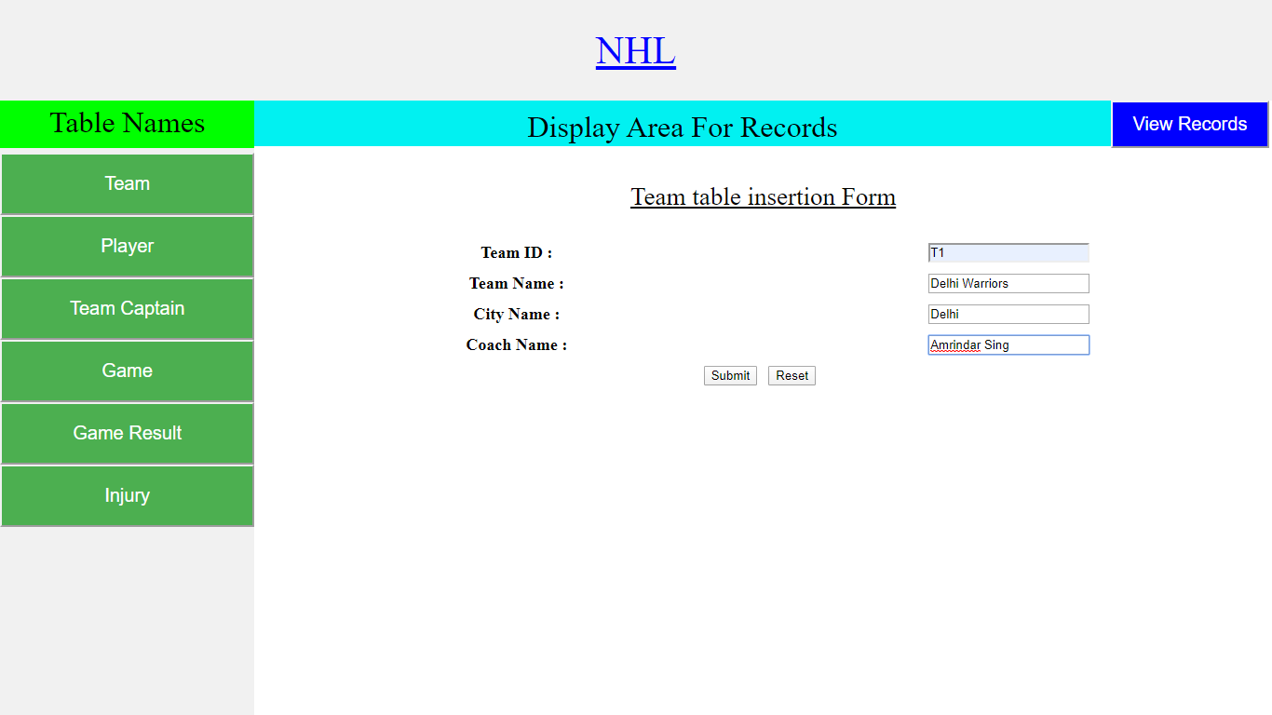

**Player Table Insertion Page:**

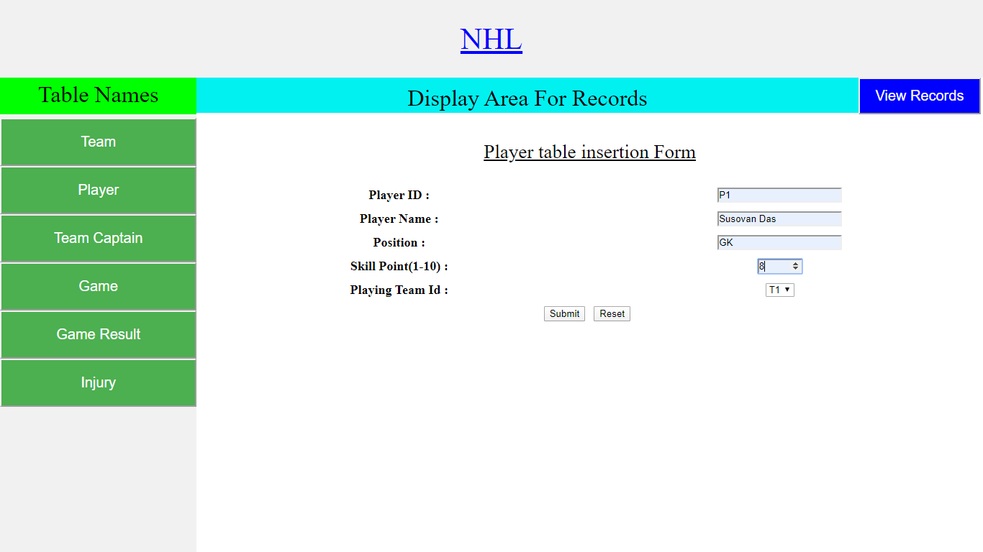

**Team_captain Table Insertion Page:**

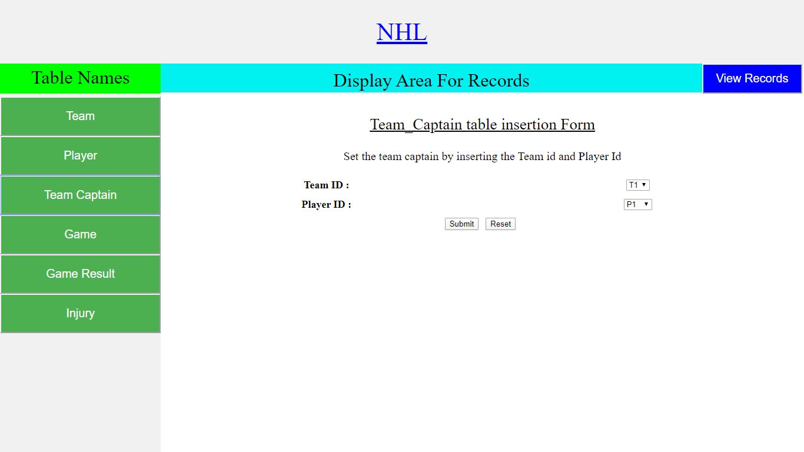

**Game Table Insertion Page:**

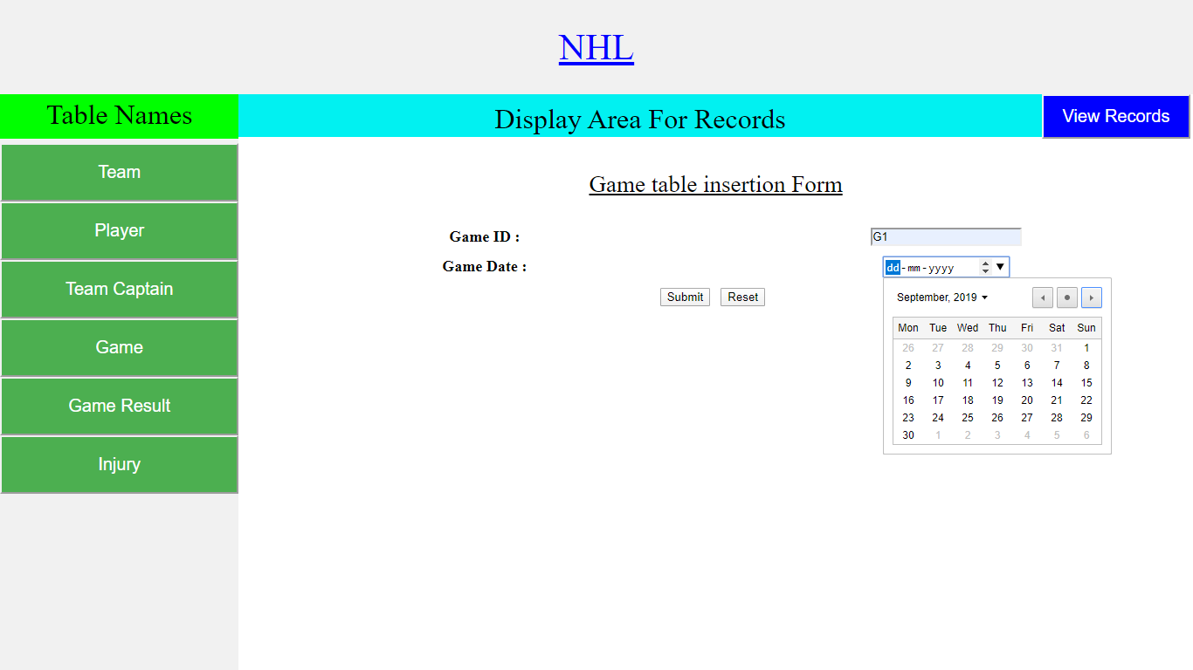

**Game_result Table Insertion Page:**

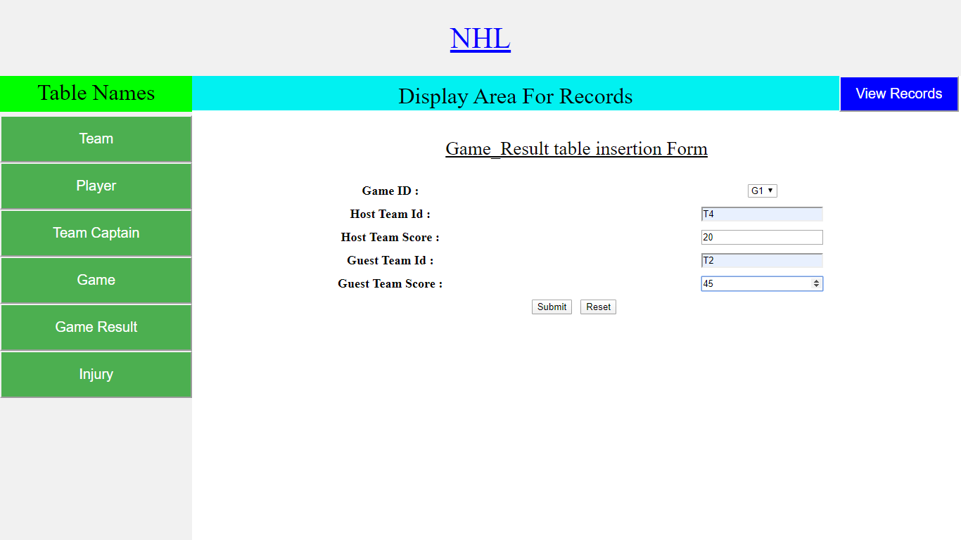

**Injury Table Insertion Page:**

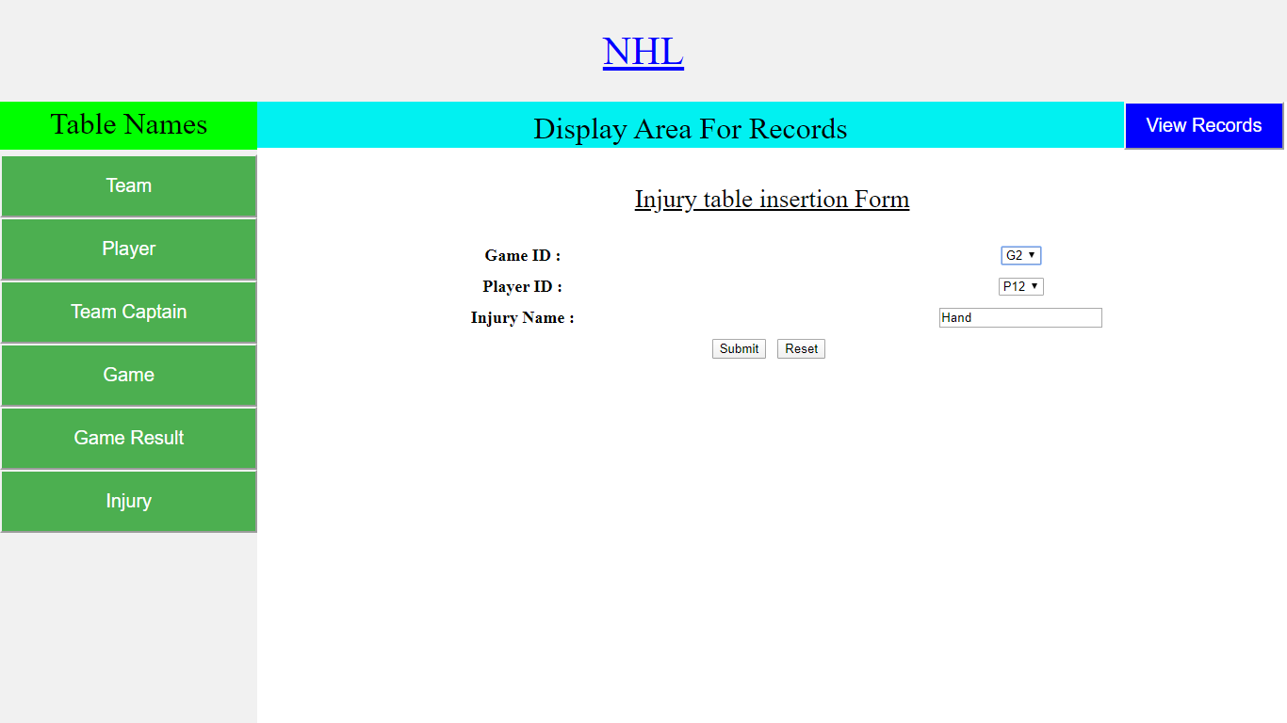

**Report Page Images:**

